This document is a tutorial for compiling Micro-Manager 2.0 plugin jars.

Please refer to <https://micro-manager.org/wiki/Version_2.0_Plugins> for reference.

the IDE in the above link is IntelliJ . Here I present an example using Netbeans12 to do the same work.

1. Open Apache Netbeans IDE 12.0
2. File->New project, select “Java with Ant” and “Java Project with Existing Sources”

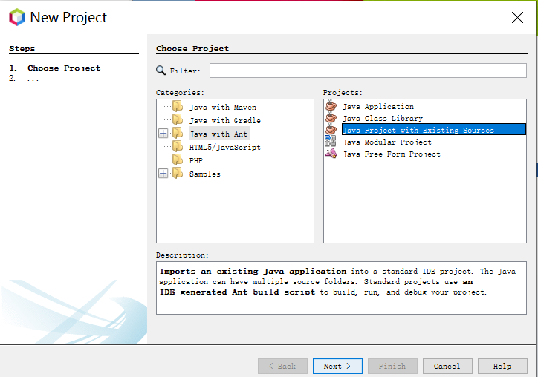

1. Click Next and give a name to the project

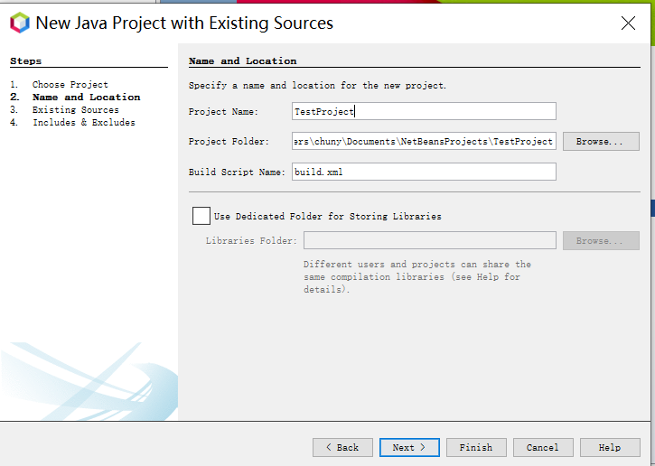

1. Click next and choose source folder:we can use $src$\plugins\Example as source folder. But since it was used in my previous test project, I copied the java files into .\src folder and added it:

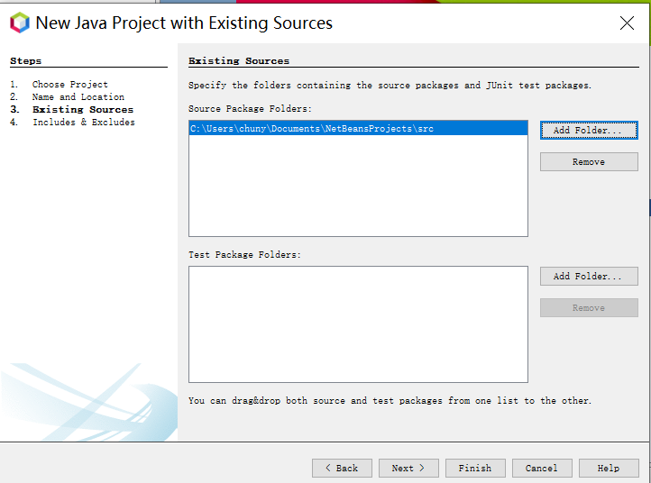

1. Finally, confirm there are two java files and click finish:

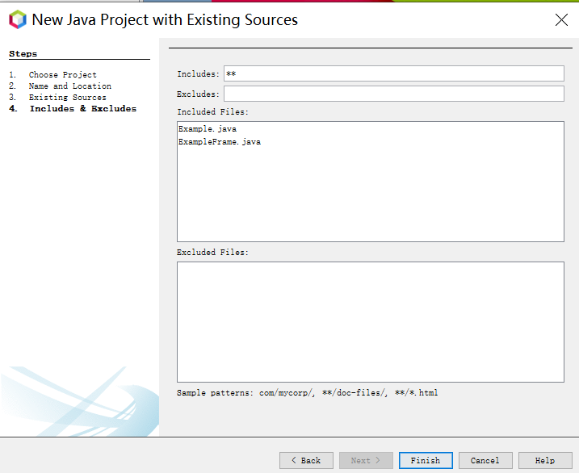

1. Then we can see the source files added with error marks and put under default package. If we put the java files in a folder structure like this “org\micromanager\example”, the package will change accordingly.

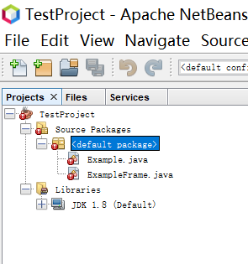

1. Now we will add libraries:right click the libraries item, add all jars in the folder of Micro-Manager installation folder \plugins\Micro-Manager\\*.jar

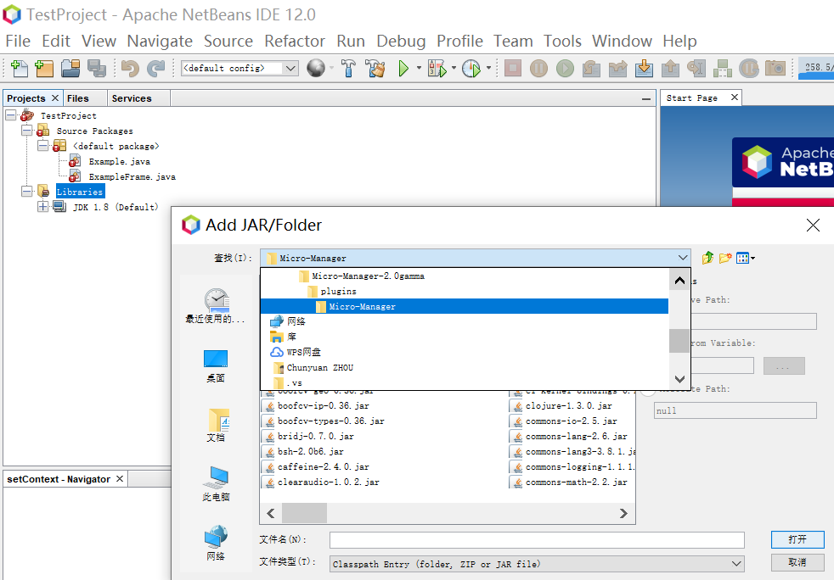

1. After adding the jar files, the error marks in the source files disappears(needs several seconds to take effect)
2. Because in step 4), we did not put source files in any package (directory structure), we have to comment off the line (also do not forget the ExampleFrame.java ):

//package org.micromanager.plugins.example;

1. Right click project to open properties to check all items. But normally we can use the defaults.
2. Click build to find the jar here :\NetBeansProjects\TestProject\dist\TestProject.jar
3. Copy the TestProject.jar to MM2 installation folder\mmplugin (not plugin) and start MM, we should find the example plugin under the \plugin\developer tools menu:

